**Investigative Skills in Science  
 Research Proposal Form**

**Project Title: Investigation of the acetaminophen in different fever and flu tablets**

| **Class** | **S2-04** | **Group:** | **D** |
| --- | --- | --- | --- |

| **SN** | **Name of student** | **Email** |
| --- | --- | --- |
| **1** | **Yeoh Tian Huai** | **yeoh_tian_huai@s2022.ssts.edu.sg** |
| **2** | **Nathan Quek** | **nathan_quek_yi_kheng@s2022.ssts.edu.sg** |
| **3** | **Justin Ang** | **justin_ang_wen_jie@s2022.ssts.edu.sg** |

| **Type of research:** | | |
| --- | --- | --- |
|  | **1** | **Test a hypothesis: Hypothesis-driven research** |
| **X** | **2** | **Measure a value: Experimental research (I)**  **Investigation of the acetaminophen in different fever and flu tablets** |
|  | **3** | **Measure a function or relationship: Experimental research (II)** |
|  | **4** | **Mathematical modelling: Theoretical sciences and applied mathematics** |
|  | **5** | **Observational and exploratory research** |

| **Category of research:** | **Sub-category:** |
| --- | --- |
| CHEMISTRY (Code: CHEM) | **Analytical Chemistry (ANC)** |
| **Reference** | [**https://www.societyforscience.org/isef/categories-and-subcategories/all-categories/**](https://www.societyforscience.org/isef/categories-and-subcategories/all-categories/) |

**Links to Sustainable Development Goals**

| **Which of the 17 United Nations Sustainability Development Goals are you trying to address in this project? (You may indicate more than 1 goals)** | | | | | |
| --- | --- | --- | --- | --- | --- |
|  | **1** | **No poverty** |  | **10** | **Reduced inequalities** |
|  | **2** | **Zero hunger** |  | **11** | **Sustainable cities and communities** |
| **x** | **3** | **Good health and well-being** | **x** | **12** | **Responsible consumption and production** |
|  | **4** | **Quality education** |  | **13** | **Climate action** |
|  | **5** | **Gender equality** |  | **14** | **Life below water** |
|  | **6** | **Clean water and sanitation** |  | **15** | **Life on land** |
|  | **7** | **Affordable and clean energy** | **x** | **16** | **Peace, justice and strong institutions** |
|  | **8** | **Decent work and economic growth** |  | **17** | **Partnerships for the goals** |
|  | **9** | **Industry, innovation, and infrastructure** |  |  |  |
| **Describe briefly the local or global issues that you are trying to solve in about 100 words.** | | | | | |
| **We are trying to ensure that flu and fever tablets have an acceptable level of acetaminophen, this will thus result in responsible consumption and production of acetaminophen, and as a result, no one will be harmed.** | | | | | |

**Research Plan**

**Project Title: Investigation of the acetaminophen in different fever and flu tablets**

**1. INTRODUCTION:**

**1.1. Background information**

**Acetaminophen, known more commonly as Panadol or Paracetamol, is a chemical commonly found in many different forms such as capsules, liquid, chewable or disintegrating tablets, and dissolving powders or granules. (FDA 2022) This chemical is widely known to alleviate physical pain and a fever reducer, however an overdose could be fatal to the consumer.**

**As commonly used over-the-counter drug, the dosages inside the medications may not be optimal for everyone, or they may use fake advertising in their advertisements. Or worse, they may be sold counterfeit drugs. (FDA Philippine)**

**1.2. Introduce the specific topic**

**The recommended dosage for acetominorphen is 4000mg for a healthy adult. However, for most adults, it is recommended to not exceed 3000mg of acetominorphen per day (Harvard 2020).**

**Yet, acetominorphen overdose is the second most common cause for liver transplantation globally and the most common cause in the US. It is responsible for 56000 A&E visits, 2600 hospitalisations and 500 deaths per year in the US (NLM 2022)**

**Thus, if we are able to investigate and find out the acetaminophen dosage in flu and fever tablets that people normally buy, we may be able to warn them to look at the dosage of acetaminophen, thus we may develop a tag that says this product’s dosage is suitable for people from ages X to Y after investigating the acetaminophen in these products, thus, ensuring that the consumer will be safe when they consume these products.**

**1.3. Past research**

**Acetaminophen can be absorbed rapidly from the gastrointestinal tract and a dose taken by a fasting subject reaches mean peak plasma concentration in 70 minutes. It has been demonstrated that this peak can be delayed to a mean of 160 minutes with administration of propantheline which slows gastric emptying ()**

**Increasing concern was raised about the toxicity of nonprescription analgesics, but in normal use paracetamol exhibited a consistent safety profile. Its exemplary safety record was marred by the discovery in 1966 that a major overdose could be complicated by severe and sometimes fatal liver damage. (National Library of Medicine 2000). In addition to this, only 38% of people could select the appropriate dosage of Panadol.**

**In recent years, it has come to light that some “companies” are manufacturing counterfeit products for Panadol and Paracetamol, which are commonly used. As such, we are testing for acetaminophen in various different companies.**

**1.4. Conclude the Introduction**

**1.4.1 Specific objectives of the research**

**Hence, we want to measure the amount of acetominophen in the 8 different tablet brands to ensure safety in consumption by the consumer and ensure they are out of harms way.**

**In order for it to be safe, the maximum amount of acetaminophen in a pill should not exceed the result in the following equation(4000mg/No. of doses in a 24 hour period), assuming a healthy adult individual. For children, the maximum amount of acetominophen should not exceed(15mg of acetominophen per Child’s weight in kg).**

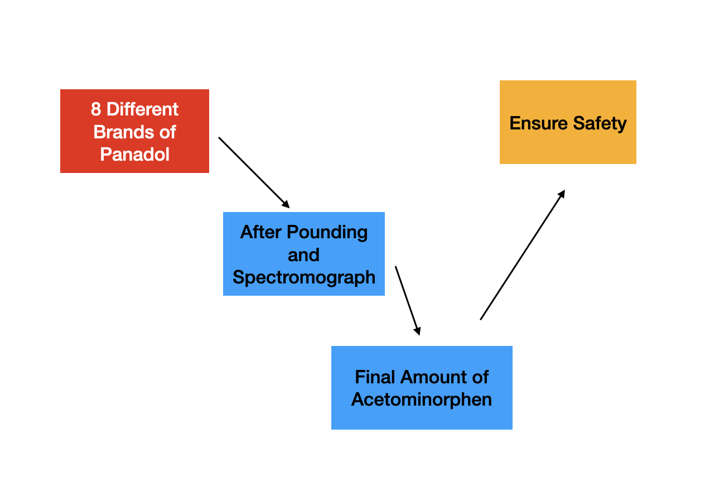

**Fig 1.1 Experimentation Process**

**Thus, through Spectromography, we can find the amount of Acetominorphen in the Panadol tablets.**

**1.4.2 Research Questions**

**Is the acetaminophen level in different fever and flu tablets from different companies safe for consumption?**

**1.4.3 Research Hypotheses**

**We decided to test the following hypothesis:**

**H1: The amount of acetaminophen in the 8 different brands of Panadol which should not exceed 500 mg per tablet (Assuming a lethal dose of 4000mg and taking 8 tablets within a 24 hour period).**

**1.4.3.1 Independent variable**

**8 Different brands of tablets**

**1.4.3.2 Dependent variable**

**Amount of Acetaminophen in the Panadol/Tylenol/ Etc Tablet**

**1.4.3.3 Controlled variables**

1. Using the same model of Spectrophotometer
2. Same duration of analysis
3. All are tablets
4. The sample mass to be mixed with water is 500mg.

**2.    Method**

**2.1 Equipment list:**

* **8 Different brands of tablets with Acetaminophen**
* **1 Mortar and Pestle**
* **8 Cuvettes**
* **1 Measuring Tube**
* **1 SpectroVis Plus SVIS-PL**
* **1 Rag**
* **1 Bottle of Soap**
* **Water**
* **A box of Sterile gloves**
* **1 Clean Filtering flask with a Vacumm adapter**
* **1 bottle of Diatomaceous Earth(Celite)**
* **Filter Paper**
* **1 Buchner Funnel**

**2.2 Diagrams**

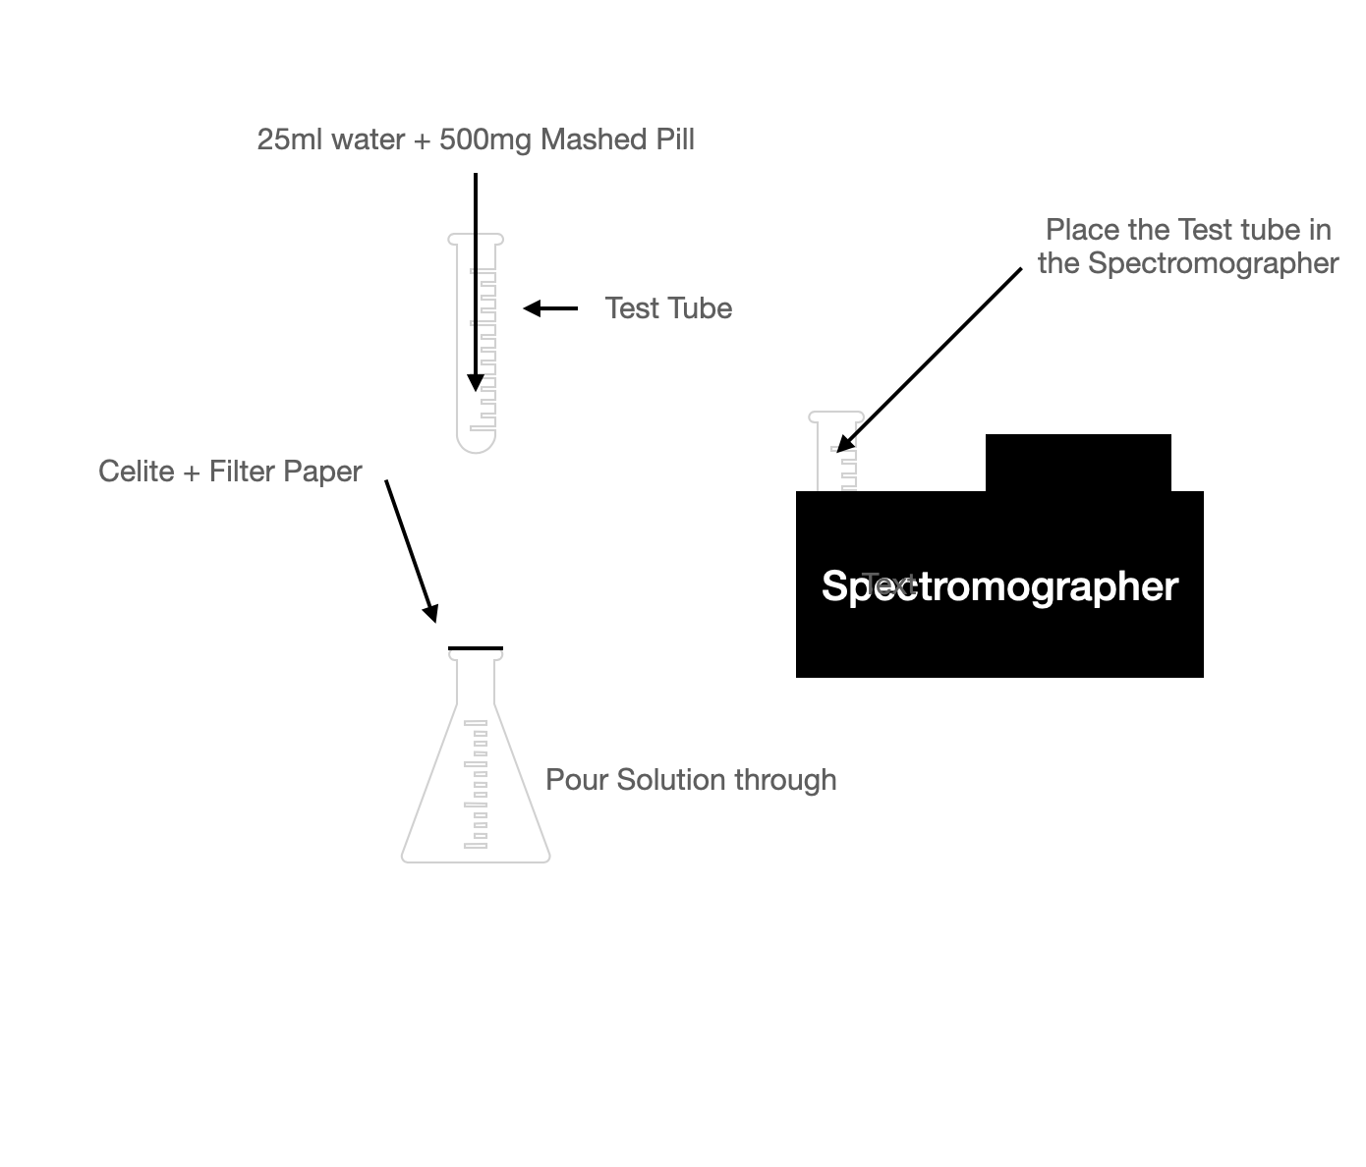

**Figure 1: Experimental setup**

**2.3 Procedures: Detail all procedures and experimental design to be used for data collection**

1. **Purchase 8 different brands of Panadol**
2. **Wear sterile gloves**
3. **Rinse and Wash the Mortar and Pastle with soap and tap water.**
4. **Once soaped, rinse of soap with water.**
5. **After rinsing, ensure no soap is left on the Mortar and Pastle.**
6. **Place 6 tablet of Panadol into the Mortar and Pastle and bash.**
7. **Ensure all of the Panadol is grinded into powder.**
8. **Take a cuvette and pour 50ml of water and rinse**
9. **Pour 25ml of water into the cuvette.**
10. **Measure 500mg of Panadol powder and pour it into the test tube.**
11. Take a Buchner funnel hooked to a vacuum tube.
12. Place a piece of filter paper on the top of a Buchner funnel.
13. Open the bag of Diateomaceous Earth(Celite) and take 1 tablespoon out.
14. Pour the Celite out of the spoon and spread it over the filter paper thinly.
15. Take a funnel and pour the water with the curvette through.
16. Take another funnel and pour the water back into the curvette.
17. Place cuvette into Spectrometer.
18. Repeat steps 2-16 for each different Panadol brand.

**2.4 Data Analysis: Describe the procedures you will use to analyze the data / results.**

**15. Tabulate the data and calculate the amount of Acetaminorphen as shown below:**

| **Sample/Reading** | **Reading 1**  **(In mg)** | **Reading 2**  **(In mg)** | **Reading 3**  **(In mg)** | **Reading 4**  **(In mg)** | **Average(Final)**  **(In mg)** |
| --- | --- | --- | --- | --- | --- |
| **1 (Panadol** Optizorb**)** |  |  |  |  |  |
| 2 (Panadol Optizorb(Expired)) |  |  |  |  |  |
| **3 (Paracil)** |  |  |  |  |  |
| **4 (Progesic)** |  |  |  |  |  |
| 5 (Tylenol) |  |  |  |  |  |
| 6 (Guardian Fever and Pain Relief |  |  |  |  |  |
| 7 (Watsons PORO Tablet) |  |  |  |  |  |
| 8 (Panadol Cough and Cold) |  |  |  |  |  |

**16. Plot a bar graph on the level of Acetaminophen**

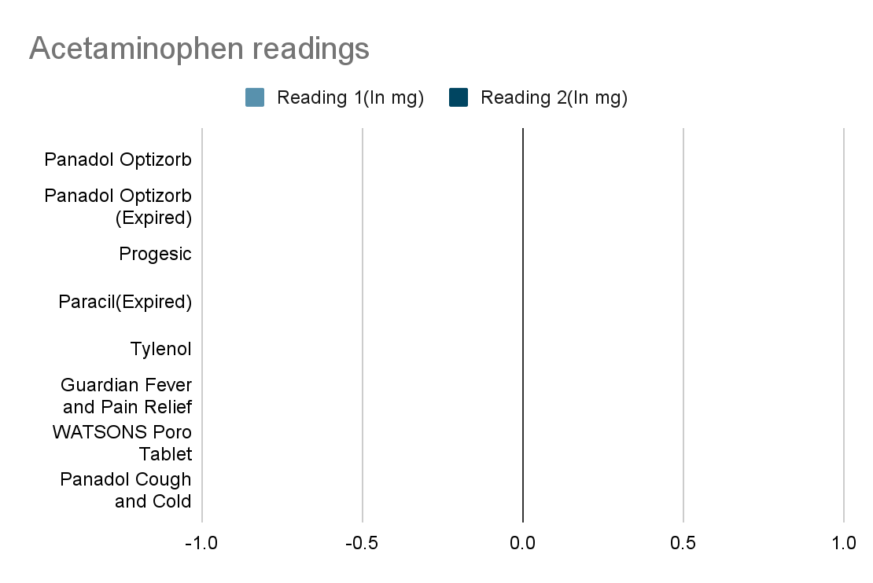

**17. Find out if the Acetaminorphen level is ≤500 mg.** Graph above should be the same as the graph below.

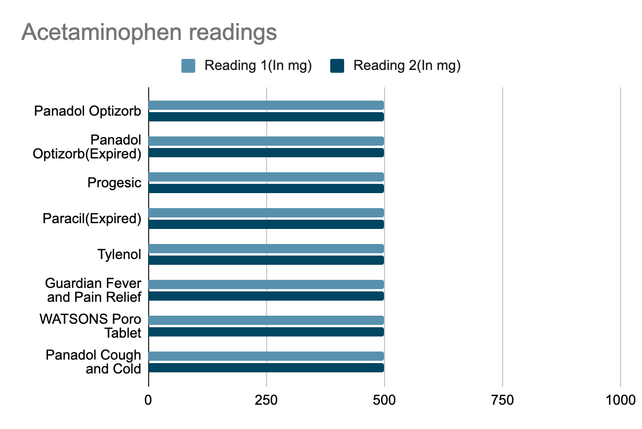

**2.5 Risk, Assessment and Management: Identify any potential risks and safety precautions to be taken.**

**Table 1: Risk Assessment and Management table**

| **Types of hazards** | **Risks involved** | **Assessment** | **Management** |
| --- | --- | --- | --- |
| Ergonomics | Accidentally inhale/eat the Acetaminophen | **Medium(After management considered low)** | **Wear masks, gloves, goggles when handling Acetaminorphen and use spatula to scoop it** |
| Physical | Hit hand when using the mortar and pastel | **Low** | Do not place finger into mortar |
| Physical | Breaking the tube | **Low** | **Throw it away into the shards bin** |
|  |  |  |  |
|  | **LEGEND** | **Low** | **Unlikely and no severe harm** |
|  |  | **Medium** | **Likely but not severe OR Unlikely but severe** |
|  |  | **High** | **Likely and Severe harm** |

**6. References**

**Agrawal, S., & Khazaeni, B. (2022, August 1). *Acetaminophen Toxicity*. Continuing Education Activity. Retrieved January 10, 2023, from** [**https://www.ncbi.nlm.nih.gov/books/NBK441917/#:~:text=Acetaminophen%20toxicity%20is%20the%20second,year%20in%20the%20United%20States**](https://www.ncbi.nlm.nih.gov/books/NBK441917/#:~:text=Acetaminophen%20toxicity%20is%20the%20second,year%20in%20the%20United%20States)

**Food and Drug Administration Philippines . (n.d.). About FDA Transparency Issuances Services FDA Advisory No. 2020-1348 || Public Health Warning Against the Purchase and Use of the following Counterfeit Drug Products: Retrieved January 11, 2023, from https://www.fda.gov.ph/fda-advisory-no-2020-1348-public-health-warning-against-the-purchase-and-use-of-the-following-counterfeit-drug-products/ ‘**

**Harvard Health Publishing. (2020, April 15). *Acetaminophen safety: Be cautious but not afraid*. Acetaminophen safe dosage basics. Retrieved January 10, 2023, from https://www.health.harvard.edu/pain/acetaminophen-safety-be-cautious-but-not-afraid**

**RSC Education. (n.d.). *Colorimetric analysis of Paracetamol - RSC Education*. Colorimetric analysis of paracetamol. Retrieved January 27, 2023, from https://edu.rsc.org/download?ac=12802**

**U.S. Food and Drug Administration . (2022, September 6). Acetaminophen. Retrieved January 10, 2023, from** [**https://www.fda.gov/drugs/information-drug-class/acetaminophen**](https://www.fda.gov/drugs/information-drug-class/acetaminophen)

**7. Bibliography**

**Durbin, K. (2022, September 29). *Acetaminophen uses, dosage & side effects*. Drugs.com. Retrieved January 10, 2023, from https://www.drugs.com/acetaminophen.html**

LF;, P. (2000, March). *Paracetamol: Past, present, and future*. American journal of therapeutics. Retrieved January 11, 2023, from https://pubmed.ncbi.nlm.nih.gov/11319582/

NPS MEDICINEWISE. (2015, May 11). *Gaps in patient knowledge*. Safe and appropriate use of paracetamol: closing the consumer knowledge gap. Retrieved January 12, 2023, from https://www.nps.org.au/news/safe-and-appropriate-use-of-paracetamol-closing-the-consumer-knowledge-gap

**PHARMACOLOGY. (1975). *Acetaminophen Poisoning and Toxicity*, *55*(6), 871–876. Retrieved January 11, 2023, from https://publications.aap.org/pediatrics/article-abstract/55/6/871/51263/Acetaminophen-Poisoning-and-Toxicity.**

**Annex: List of possible risks involved**

| **Types of hazards** | **Risks involved** |
| --- | --- |
| **Physical** | **Falling objects / Flying objects / Pointed objects / Sharp edges / Slippery surface / Abrasive or rough surfaces / Excessive vibrations** |
| **Thermal** | **Convective or radiant heat from the fire / Flame / Hot liquid or gases / Molten substances / Hot solids or surfaces** |
| **Environmental** | **Insufficient light / Extreme light / Excessive noise / High humidity conditions / High wind speed / Cold temperatures** |
| **Chemical** | **Toxic / poisonous chemicals / Corrosive substances / Irritant chemical** |
| **Flammable**  **Materials** | **Flammable solids / Flammable liquids (alcohol) / Flammable gas (H2, O2) / Reactive metals (Al, Mg, K, Na) / Flammable oils** |
| **Radiation** | **Ionising / Non-ionising** |
| **Biological** | **Virus / Bacteria / Fungi** |
| **Ergonomic** | **Over exertion during reaching, carrying, lifting / Psychological stress / Falling from height / Drowning / Overcrowding** |
| **Equipment (use)** | **Physical exhaustion and heat stress / Cuts / Burns / Electrical shock / Electrical arcs / Static electricity** |

**Note: All wet experiments must not be done near tables with electrical sockets.**